April 11, 2017

DAL#: DAL-17-08
Subject: Revised ACF Closure Guidelines

Dear Adult Care Facility Operator:

The purpose of this letter is to inform Adult Care Facility (ACF) Operators and Administrators that the Adult Care Facility Closure Guidelines have been revised. Newly added or revised components include the following:

Upon closure of the facility and transfer of the last resident(s):

- the facility is required to submit their Class 3A Controlled Substance License to the Bureau of Narcotic Enforcement.

- the closure plan should have a procedure in place to indicate that the e-FINDS scanner will be returned to the Department of Health.

- the facility will contact the New York State Commerce Accounts Management Unit (CAMU) to request closure of their Health Commerce System (HCS) Account.

If you have any questions related to the revised closure plan guidelines, please contact
the Program Manager in your Regional Office.

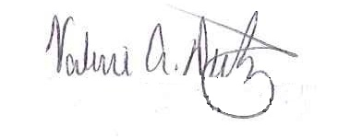
Sincerely,

Valerie A. Deetz, Director
Division of Adult Care Facility and Assisted Living
Surveillance

cc: M. Henessey
P. Hasan
J. VanDyke
B. Barrington
N. Nickason

